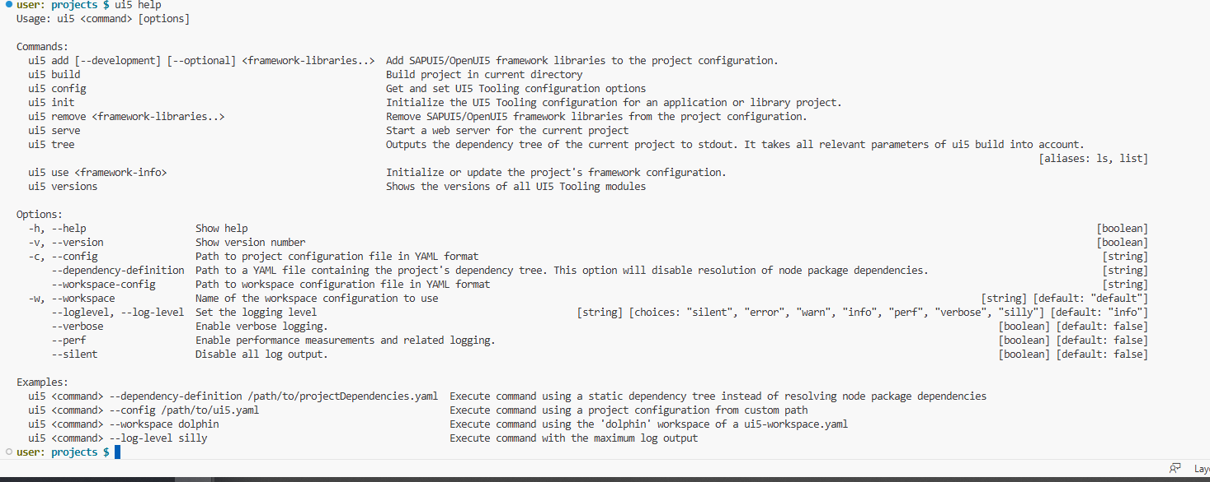

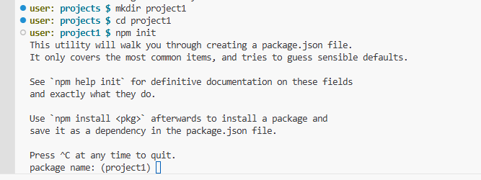

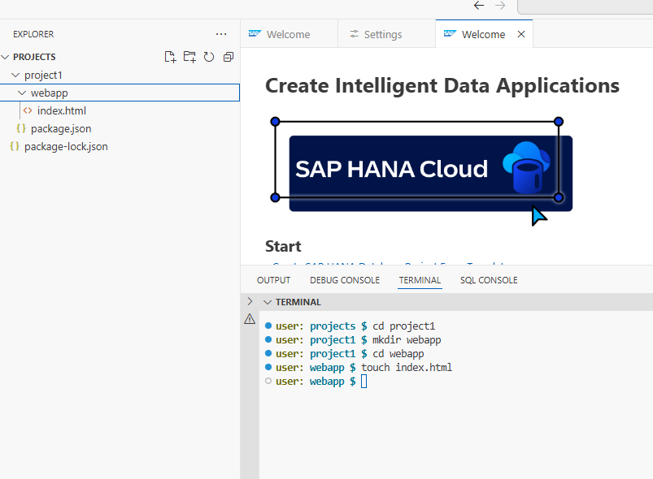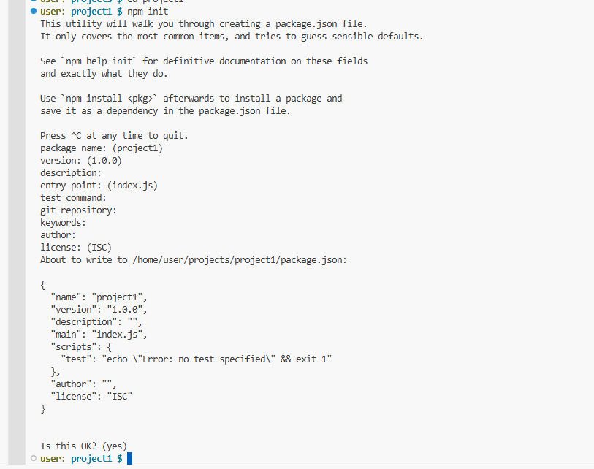

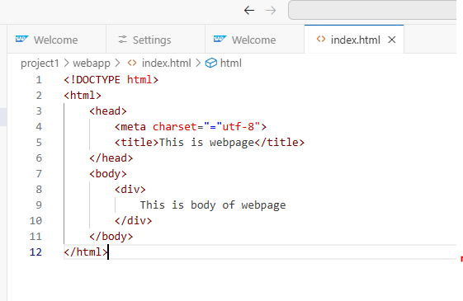

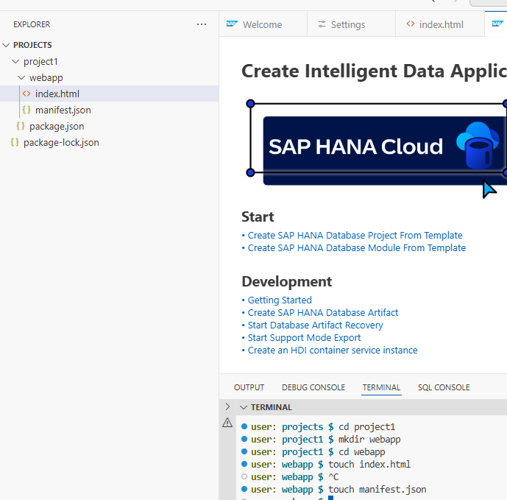

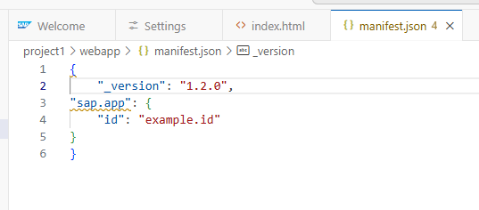

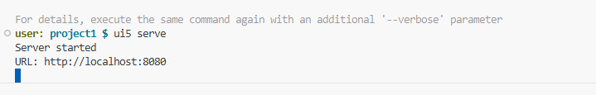

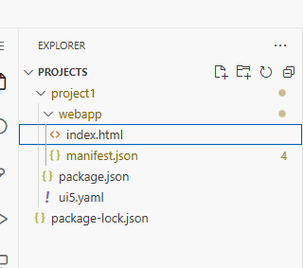

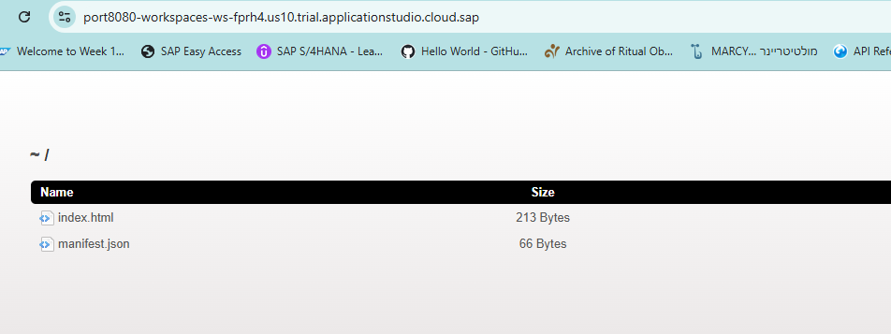

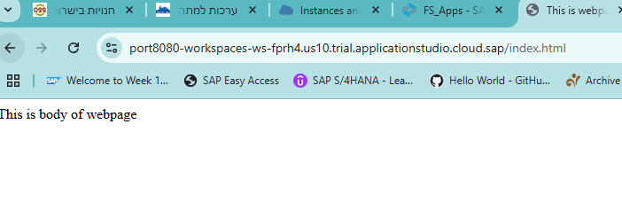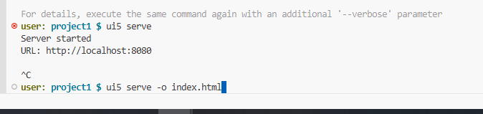

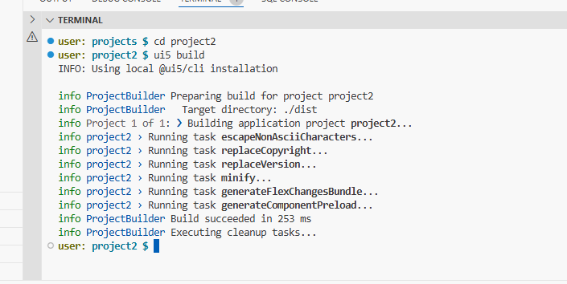

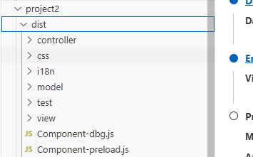

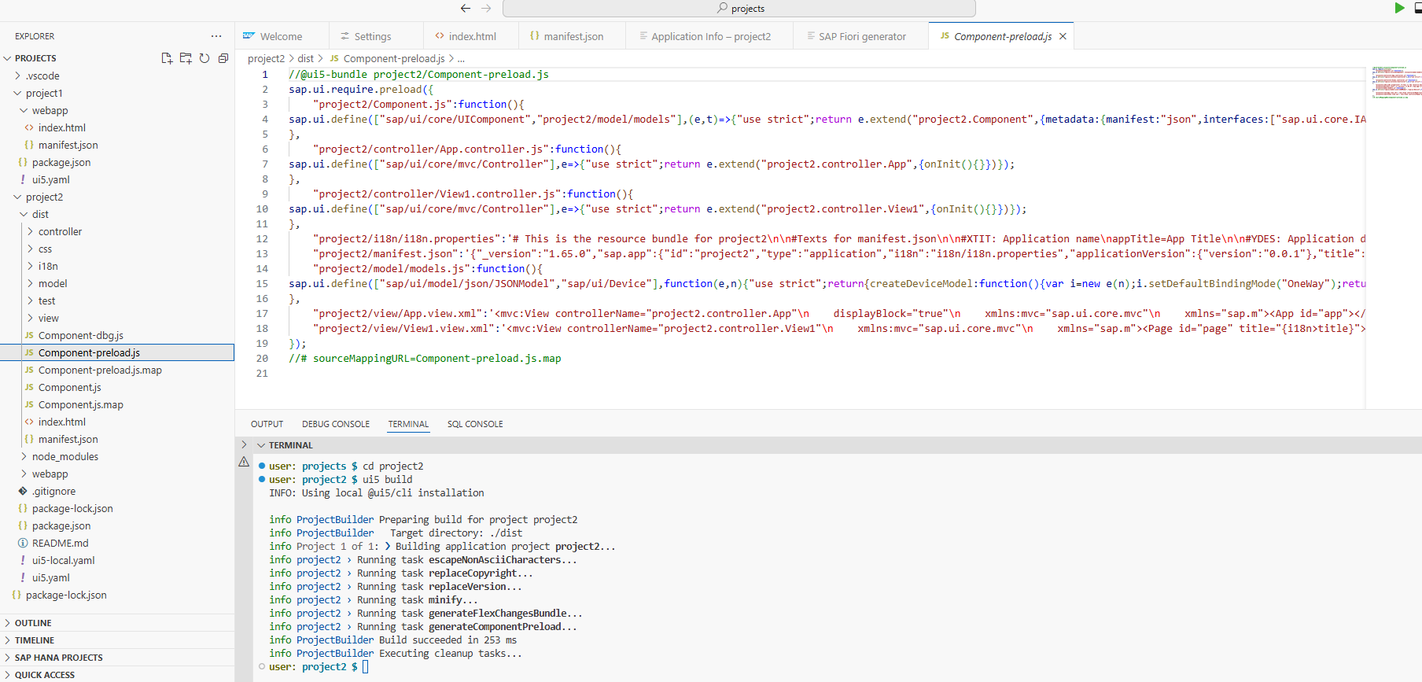

[https://sap.github.io/ui5-tooling/v3/pages/CLI/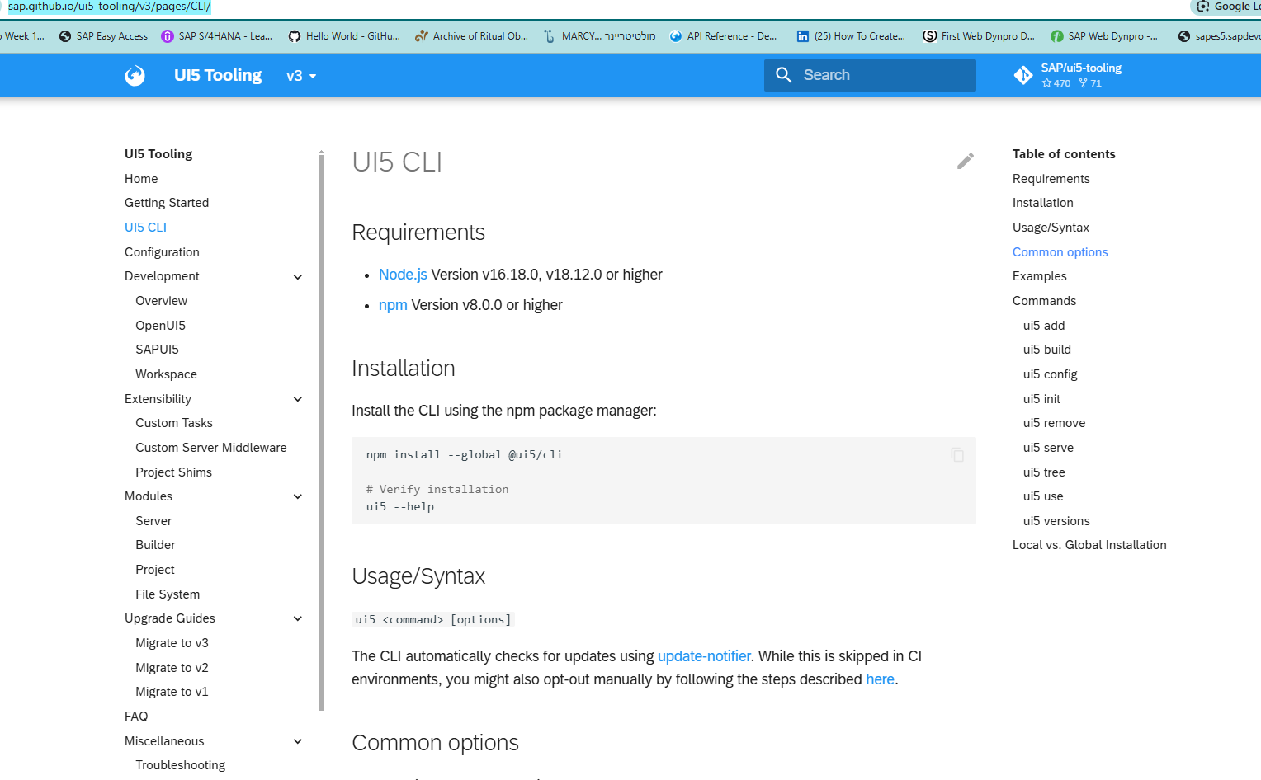](https://sap.github.io/ui5-tooling/v3/pages/CLI/)



So this is entire SAP web application bundled into this component.

Preload dot js.

When we run this Ue5 application in a browser.

Instead of loading these files independently, the browser is going to load component preload dot js.

This component preload dot js will have all the minified code.

See here.

This is all the minified code.

This is not the code which is there inside this app.

Dot controller.

Sorry.

Inside this particular controller.

So these are the original controllers.

App debug dot controller.

Dot JS is the original controller and this is the minified format you are not able to I mean generally

not many people will try to understand the minified format.

Only browser will load this minified format to improve the performance of the application.

So this is one more way of using Uf5 tooling.

So there are n number of commands which we can use for the UI for tuning.

If we come back here we can see Uf5 add is there Uf5 build.

So we have used Uf5 init Uf5 serve Uf5 build.

We can also try to use Ue5 ad as well.

So if we just click here, here are the examples.

If I want to use these libraries just copy this command here.

Come back to this project two and paste it.

And now press enter button.

So there is some issue it seems.

So it is suggesting us to use this command I believe.

So I just copied it.

Now just paste it here and try to use.

